Safety Council of Greater St. Louis Annual Membership Program

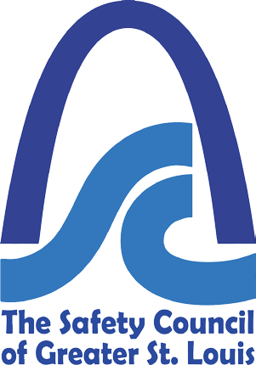

Promoting Community Safety since 1916

Ensuring that everyone in our community returns home, safe and healthy, every day

Introducing Our Annual Membership
The Safety Council of Greater St. Louis is celebrating our 100th year committed to making our community a safer
place in which to live, work and play. Our Vision is to ensure that everyone throughout our community returns
home safe and healthy every day. We are inviting you to become a member of the Safety Council of Greater
St. Louis and help us make our vision a reality.

The Benefits of Membership
- Vision Focus: all members of our community, beginning with our young drivers who are most at risk for accidents. Included in your membership: the opportunity to host Alive @ 25 for children of your employees at an affiliated location to make a positive impact on our drivers. One COMPLIMENTARY 4 hour training session for each membership at your location or ours (for up to 15 students).
- NEW in 2019 Vision Focus: Corporate Safety. Due to our partnership with MSDSonline, all Safety Council of Greater St. Louis Members receive a Special Discount on MSDS online Membership. Form more information visit https://www.msdsonline.com/pp/safety-council-of-greater-st-louis/
- Vision Focus: all members of our community, continues with our commuters most at risk when driving to and from work or business. Included in your membership: The opportunity to host or defensive driving courses for your employees. One COMPLIMENTARY employee training with every 15 employee registrants.
- Vision Focus: all members of our community, the future of safety in our workplace. Join the Safety Council to participate in the SURVEY INSTITUTE Safest Places to Work Survey to discover your work places individual deliverables along with the broader benefits and insights from local participation that are actionable for your work place.
- Our other corporate training courses can be tailored to fit your company needs and schedules.
- Our vision includes communication within our community and we will offer our members 2 free admittances to
our Breakfast Meetings. Presentation opportunities are also available.
- Company recognition on our web site and sponsored events.
- Job postings on our web site for positions of relevancy.
- Your membership also supports this 501 c nonprofit organization that has been a pillar of our community since
1916 and includes Safetyville, court ordered programs and outreach to those in our community.
The Safety Council of Greater St. Louis is Committed to Providing Solid Learning Experiences to Build Strong Work Place Leaders and Strong Communities

Please Print:

Name (First/Last): |  | Title:
Company:
Address:
City: | State: | Zip:
Telephone: | Email:
Terms and Conditions: Non Refundable

Please Call Mary Beth at 314-621-9200 for Additional Information
$150.00 Membership (1-25 employees)
$250.00 Membership (26-300 employees)
$500.00 Membership (301-750 employees)
$700.00 Membership (751-999 employees)
$1000.00 Membership (>1000 employees)

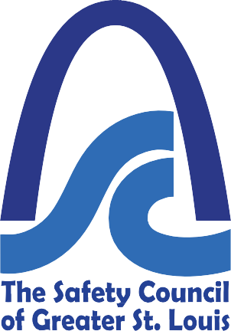
Board of Directors
Bryan Berry — Crane Insurance Agents and Brokers
Barry Stelzer — Carpenters District Council
Dave Hunyar – ARCO Construction
Jason Wernex — Ameren
Julie O’Keefe — Armstrong Teasdale LLP William McDonald — OSHA
Chris Janson — Haines, Janson & Associates Mark Jaeggi — Monsanto
Steve Williams — French Gerleman
Kevin Maitland — McCarthy Building Companies, Inc.
Joe Wickenhauser – Olin Brass

Contact Us
Safety Council of Greater St. Louis 2019Annual Membership Form
2330 Hampton Avenue St. Louis, MO 63139 314-621-9200 phone
314-621-9204 fax
www.stlsafety.org

Mary Beth Proost
Executive Director mb.proost@stlsafety.org

